CONTRACT DOCUMENTS

For

WASHINGTON COUNTY

2024 GUIDERAIL

Washington County, Pennsylvania

Contract # 032624- WC Guiderail

Washington County, Pennsylvania



Prepared By

Washington County Planning Commission

100 West Beau Street, Suite 701

Washington, PA 15301

CONTENTS

NOTICE TO BIDDERS NB-1

INFORMATION FOR BIDDERS IB-4 TO IB-7

INSTRUCTIONS TO BIDDERS INS-8 TO INS-11

BID DOCUMENT BD-12 TO BD-14

BID BOND BB-15 TO BB-16

AGREEMENT A-19 TO A-21

PERFORMANCE BOND PB-22 TO PB-23

LABOR AND MATERIAL PAYMENT BOND LMPB-24 TO LMPB-26

WARRANTY BOND WB-27 TO WB-29

NOTICE TO PROCEED NTP-30

CHANGE ORDER CO-31

GENERAL CONDITIONS GC-32 TO GC-42

ANITCOLLUSION AFFIDAVIT……………………………………… AA-43 TO AA-44

TECHNICAL SPECIFICATIONS……………………………………….TS-45 TO TS-71

PREVAILING MINIMUM WAGES……………………………………per attachment.

NOTICE TO BIDDERS

Notice is hereby given that Washington County will be receiving sealed bids for ‘Washington County Guiderails 2024’ for the County to purchase at the Office of the County Controller, to be mailed or delivered to, 100 West Beau Street, Suite 403, Courthouse Square Office Building, Washington, PA 15301, until 11:00 A.M. Prevailing Time, on Tuesday, March 26, 2024. All submissions shall contain one original and one unbound copy. Bids will be promptly opened at the time indicated above. Late submissions will not be accepted.

The above-mentioned bid document may be obtained on or before Monday, March 4th from the Washington County website at Washington County PA: Official Website (washingtoncopa.gov). Vendors receiving bid documents are responsible for checking for contract changes and addenda at the website.

All bids must be in the format requested and must comply with all applicable laws, regulations, and specifications. Washington County reserves the right to reject any and all bids.

Interested parties may email any written request for clarifications or information to the Washington County Purchasing Office to Dalton Thompson at dalton.thompson@co.washington.pa.us or to Randy Vankirk at vankirkr@co.washington.pa.us. Any requests for clarifications are due to be received no later than March 16th, 2024. Inquiries will not be accepted orally or via phone. Requests for Information (RFI’s) will be distributed and responded to in the timeliest manner available and in question-and-answer form. Responses will be posted to the County website as listed herein in the form of an addendum.

Washington County will not be held responsible for any incorrect information obtained from any source other than from Washington County.

SEALED BID SUBMISSION MUST BE MARKED:
BID: Washington County 2024 Guiderail
Contract No. 032624-WC 2024 Guiderail

WASHINGTON COUNTY BOARD OF COMMISSIONERS:
NICK SHERMAN, CHAIRMAN
ELECTRA JANIS, VICE-CHAIR
LARRY MAGGI

To be advertised March 4th and March 11th , 2024

NB-1
INFORMATION FOR BIDDERS

1. Description of Work

A. The description of work to be completed under this Contract is as follows:

The work for the Washington County 2024 Guiderail project in Nottingham Township, Washington County, Pennsylvania, shall include, but is not necessarily limited to

- Maintenance and protection of traffic.
- Installation of guiderail.

B. Project will be completed 90 calendar days after the date of the Notice to Proceed, anticipated to be April 8, 2024.

C. Inspection trips for prospective bidders may be arranged by contacting:

VINCENT P. LEY, P.E.
WASHINGTON COUNTY ENGINEER
WASHINGTON COUNTY PLANNING COMMISSION
100 WEST BEAU STREET, SUITE 701
WASHINGTON, PENNSYLVANIA 15301

PHONE: (724) 228-6811

2. Bid Submission

A. Each bid must be submitted in a sealed envelope addressed to:

WASHINGTON COUNTY CONTROLLER
100 WEST BEAU STREET, SUITE 403
WASHINGTON, PENNSYLVANIA 15301

IB-1
- The sealed envelope containing a bid must be plainly marked on the
outside as:

BID FOR: CONTRACT #031924-WC Guiderail
“WASHINGTON COUNTY 2024 GUIDERAIL”
WASHINGTON COUNTY, PENNSYLVANIA

C. The envelope should bear on the outside the name of the Bidder, Bidder address, Bidder license number, if applicable, and the name of the project for which the bid is submitted. IF FORWARDED BY MAIL, the sealed envelope containing the bid must be enclosed in another envelope addressed to the Owner at:

WASHINGTON COUNTY CONTROLLER
100 WEST BEAU STREET, SUITE 403
WASHINGTON, PENNSYLVANIA 15301

D. All bids must be made on the required bid forms. All blank spaces for bid prices must be filled in, in ink or typewritten, and the bid form must be fully completed and executed when submitted. Submit the required forms as one original + three copies (1 unbound).

E. The following items shall be submitted with each bid:

1. Completed BID DOCUMENT, including SCHEDULE OF PRICES and COMPONENT ITEM SCHEDULE.

- BID BOND in the amount specified. (Either Bid Bond, Certified Check, Cashier’s Check, Cash, Bank Good Faith Check, or other Irrevocable Letter of Credit.)

- Completed ANTI-COLLUSION AFFIDAVIT.

3. Right to Reject or Withdraw

A. Owner may waive any informalities or minor defects or reject any and all bids. Bidder may withdraw his bid by making a properly authorized and executed written application to the Controller's Office prior to the deadline for the submission of bids.

IB-2
4. Bidder's Responsibility
A. Bidders must satisfy himself of the extent of the work by examination of the site and a review of the drawings and specifications, including Addenda. After bids have been submitted, the Bidder shall not assert that there was a misunderstanding concerning the extent of work, nor of the nature of the work, to be done.

B. Contract Documents contain the provisions required for the construction of the project. Information obtained from an officer, agent, or employee of the Owner, or any other person, shall not affect the risks or obligations assumed by the Contractor, or relieve him from fulfilling all of the conditions of the Contract.

C. Each Bidder is responsible for inspecting the site and for reading and being thoroughly familiar with the Contract Documents. Failure or omission of any Bidder to do any of the foregoing shall in no way relieve Bidder from all obligations in respect to his bid.

5. Bid Security
A. Bid must be accompanied by cash, certified check, cashier’s check, bank good faith check, other irrevocable letter of credit or bid bond in the amount of 10% of the total bid and made payable to the order of the Washington County Commissioners. Only the Bid Securities listed will be accepted.
The bid bonds of the unsuccessful bidders will be returned. The Bid Bond of the successful bidder will be retained until the Payment Bonds, Performance Bonds, and insurance documents have been executed and approved, after which it will be returned.

6. Requirements for Signing Bid Documents
A. Bid Documents which are not signed by individuals making them shall have attached thereto a Power of Attorney with authority to sign the document in the name of the person for whom it is assigned.

B. Bid Documents which are signed for a partnership shall be signed by all of the partners or by an attorney-in-fact. If signed by an attorney-in-fact, there shall be attached to the Bid Document the Power of Attorney executed by the partners.

- Bid Documents signed for a corporation shall have the correct corporate name thereon, and the signature of the President or other authorized officer of the corporation manually written below the corporate name following the word "By _______________________." Any Document manually signed by an official other than the President of the corporation shall have attached to it a certified copy of a resolution of the Board of Directors directing authority of such official to sign the Bid Document. The Bid Document shall also bear the attesting signature of the secretary of the corporation, and the impression of the corporate seal.

IB-3
7. Addenda and Interpretations

- No interpretation of the meaning of the plans, specifications, or other pre-bid documents will be made to the bidder orally. Every request for such interpretation should be in writing addressed to Washington County,

Addressed to:

Randy Vankirk, Director of Purchasing
95 West Beau Street, Suite 430
Washington, Pa. 15301

Or Emailed to: or to vankirkr@co.washington.pa.us

and to be given consideration must be received at least ten (10) days prior to the date fixed for the opening of the bids. Any and all such interpretations, and any supplemental instructions will be in the form of written addenda to the specifications which, if issued, will be mailed to all prospective bidders (at the respective addresses furnished for such purpose), not later than seven (7) days prior to the dated fixed for the opening of bids. Written addendums will also be posted on the Washington County website: www.co.washington.pa.us . Failure of any bidder to receive any such addendum or interpretation shall not relieve such bidder from any obligation under this bid as submitted. All addenda so issued shall become part of the Contract Documents.

- Relative to these Contract Documents, the term "Owner" shall mean
Washington County.

8. Prevailing Wages

- Prevailing Wages apply to this project and are attached.
- Contactor to provide certified payrolls weekly as well as provide certified payrolls for each subcontractor on a weekly basis.

IB-4

INSTRUCTIONS TO BIDDERS:
1. Bidder Responsibility – Bidder is expected to be thoroughly familiar with all specifications and requirements of this bid. Failure or omission to examine any relevant form, article, site or document will not relieve you from any obligation regarding this Bid. By Submitting a Response, you are presumed to concur with all terms, conditions and specifications of this Bid unless you have specifically, by Section number, raised objection in writing and submitted it with your bid. Objections we consider excessive or affecting vital terms may reduce or eliminate your prospects for award.

2. Bidder may withdraw his bid by making a properly authorized and executed written application to the Controller's office prior to the deadline for the submission of bids. Certain bids may be withdrawn after the bid opening if in compliance with the act of January 23, 1974, P.L. 9 No.4 : 1 et seq. 73 PS : 1601 et seq.

3. Contract – By submitting a bid, the Bidder warrants that if the County makes an award to the Bidder, the Bidder shall, at the option of the County, enter into a written contract with the County. This contract shall consist of the terms and conditions set forth in the Bid, Bulletins (if applicable), Specifications, and these Instructions to Bidders. If no bid bond or substitute is required and Bidder shall pay to the County the difference in the amount specified in bid and the amount County shall pay to fulfill the specifications.

4. Permits and Fees - If applicable, the Contractor shall secure and pay for, all permits, fees licenses and inspections necessary for the proper execution and completion of the work which are customarily secured after execution of the agreement and which are legally required.

5. Other Entity Use - The successful Bidder may be requested to convey the bid prices, contract terms and conditions to municipalities or other governmental agencies within the County of Washington.

All orders, deliveries and invoices will be the responsibility of the participating governmental agencies. Washington County will not be responsible for any orders, deliveries and invoices placed by the participating governmental agency.

6. Contract Approval – The Washington County Board of Commissioners must approve the contract resulting from this solicitation.

A sample contract may be attached for review as part of this solicitation. Exceptions to the County’s standard contract form may result in rejection of the bid or proposal. The County will prepare a formal contract specific to this solicitation for execution by the successful Contractor & the Board of County Commissioners.

7. Sample Form Contract – The County’s form contract may be attached as part of this solicitation. The vendor’s submission of a bid response without identifying exceptions expressly acknowledges and formally evidences the vendor’s acceptance of all terms and conditions of the form contract. Any and all exceptions must be submitted in writing in the vendor’s bid response.

If the vendor submits an exception, which alters the County’s risk, liability, exposure in, or the intent of this procurement, the County reserves the right in its sole and absolute discretion to deem the vendor non-responsive.

All vendors further understand and agree that the County will accept no vendor exceptions to the form contract at any time after submission of the bid response.

8. All contracts entered into will be executed in Washington County, Pennsylvania. The parties acknowledge that the jurisdiction and venue for any dispute or any occurrence hereby arising out of the contract or out of performance of the contract or any other matter relating to Washington County shall be in the Court of Common Pleas of Washington County, Pennsylvania, and in no other location. This provision shall be deemed to be an integral part of any contract entered into by any Contractor with Washington County.

9. There will be no changes to an executed agreement without prior written approval by the Board of County Commissioners in the form of an addendum or change order. Types of changes include but are not limited to change in scope of work, extension of contract terms, unit pricing or total cost.

10. The County is required by State and Federal regulations to determine if any employee or contractor or vendor is excluded from participation in any Medicare, Medicaid, or other health care program. If it has been determined that any employee or contractor, both individual and entity, is on the exclusion list, said individual or entity must be reported to the Department of Public Welfare’s Bureau of Program Integrity (BPI). Furthermore, in order to preserve funding through these programs, the County is required to immediately terminate excluded employees and to immediately terminate any contact with any vendor who is either on an exclusion list or employs an individual or individuals who are on such lists.

Federal health care programs (including Medicaid and SCHIP programs) are prohibited from paying for any goods or services furnished, ordered, or prescribed by excluded individuals or entities. Washington County will have no alternative but to cancel any existing contracts with excluded vendors or vendors who employs an

INS-1

excluded individual or entity. The County will not be responsible for any payment of goods or services furnished, ordered, or prescribed by excluded individuals or entities.
Bidders responding to bids or proposals affected by these regulations accept an affirmative duty to verify that neither Bidder nor Bidder’s employees have been excluded from participation in Medicare, Medicaid, or any other health care program pursuant to Pennsylvania Department of Public Welfare (DPW) Medical assistance recommendations interpreting the United States Department of Health and Human Services' Office of Inspector General's regulations.

All County contracts with any contractor identified as meeting the criteria requiring exclusion screening must include the requirement that the contractor will develop and institute exclusion screening policies and procedures that conform to DPW recommendations and County requirements to assure compliance with federal regulations concerning suspension/debarment of all covered individual and entities.

11. Washington County may request a complete background search of any individual working on County projects to determine if the individual has committed any serious acts and has been cleared by the Pennsylvania State Police before being hired by the Contractor and placed on the job in County facilities.

12. Washington County may request proof of financial stability. Request for financial statements may be for the past three years or other methods of proof. The County may secure financial information about the Bidder from third-party sources such as, but not limited to, credit reporting agencies, Dun & Bradstreet, and other firms to which the Bidder has provided services.

13. By submitting bid offer or proposal, Bidder certifies that Bidder does not and will not during the performance of this contract employ illegal undocumented workers or otherwise violate the provisions of the “Federal Immigration Reform and Control Act of 1986."

14. SUBCONTRACTING - Any person undertaking a part of the work under the terms of the contract, by virtue of an agreement with the contractor, who, prior to such undertaking must receive the written approval of the Director of Purchasing. The County may terminate the contract if the subcontracting is done without the Director of Purchasing’s approval. Invoices relating to any work performed by a subcontractor are subject to non- payment if prior written approval has not been received by the Director of Purchasing.

15. TERMINATION - This Agreement shall continue in force until the end of its term and shall automatically terminate at the end of its term unless County terminates this Agreement earlier by providing thirty (30) days notice to Contractor of its intent to terminate.

County may terminate this Agreement at any time for any reason with or without cause; however, in the event County elects to terminate this Agreement, Contractor shall be entitled to compensation for services provided up to the point of termination.

16. If any alleged errors are noted in the bid specifications, Bidder should immediately notify the county and, if confirmed, a bulletin shall be sent to all Bidders. A copy of all bulletins issued shall be submitted with the bid documents to the County.

17. In completing the bid documents, Bidder should not add, delete or vary any of the terms or conditions or the documents prepared by the County. If Bidder makes any substantial changes in any of the documents, the county may, in its discretion, either reject the bid or waive the discrepancy. Bidder warrants that all goods and services described by Bidder in its proposal, and all samples submitted by Bidder to the County shall conform to the specifications. The Director of Purchasing & the County Solicitor may waive insubstantial errors in the bid proposal and specifications.

18. Bidder must be merchant dealing in the goods and services on which they bid and must be qualified to advise as to their application and use. Bidder warrants, and must be able upon request, to demonstrate to possess the knowledge, experience, skill, capital, stock, charters, licenses, permits, patents and personnel necessary to satisfactorily perform the contract for which they submit bids.

19. The County may, at its discretion, provide a bid form in electronic file (EXCEL spreadsheet format). If applicable for this project, the electronic file may be downloaded from our website, or is included with bid documents made available as outlined in the Invitation for Bids. Be advised that use of the bid form made available electronically is at the Bidder’s discretion. Bidder assumes full responsibility for the integrity of the completed bid form submitted and acknowledges that no changes or alterations to the bid form structure or content, other than the Bidder’s pricing, are allowed. Should any changes or alterations to the bid form structure or content be detected, the bid may be determined to be non-responsive and, therefore, disqualified.

The County reserves the right to correct formula errors on the bid form.

20. Bidder will quote price for such quantities as shown and no change in price will be made during the period of the contract.

21 Washington County reserves the right to add additional like supplies and/or service to existing bid contract throughout term of contract based on an agreed upon cost.

Additional like service or supplies are not to be provided without written approval. If prior approval has not been received, invoices are subject to non-payment.

22. All work or commodity exceeding $21,300 must receive prior approval by the Board of County Commissioners.

23. One price only will be considered for each item. When two prices are quoted both will be rejected.

INS-2

24. All items subject to testing after delivery.

25. Unless otherwise provided in the specifications, all goods supplied to the County will be from new, unused, or current stock.

26. Warranty - Unless otherwise noted by Washington County in the general terms and conditions, the Bidder warrants that all products, equipment, supplies, and or service delivered under this contract shall be covered by the industry standard or better warranty. All products and equipment shall carry a minimum industry standard manufacturer’s warranty that includes materials and labor. Dealer/Distributers agree to assist the purchaser in reaching a solution in a dispute over warranty’s terms with the manufacturer.

27. No Bidder may submit more than one bid for the same item, nor may he submit multiple by or through the agency of any partner, employee, or other person

28. By submitting a bid, the Bidder agrees to DELIVER TO the County, at the County's request at no additional cost to the County, samples of any goods or workmanship bid. Said samples will be returned to the bidder, if requested within ten (10) days of bid award; provided, however, that the County shall not be liable for damage to or destruction or consumption of these samples occurring in the ordinary course of reasonable inspection and testing. Inspection or testing by the County does not constitute a waiver of any claims or rights which the County would otherwise have with respect to the quality of goods or workmanship.

29. Unless otherwise provided in the specifications, any references in the specifications to the quantities of goods or frequency of services to be provided to the County are estimates, and the County reserves the right to require the successful Bidder to provide more or less than the estimated quantity or frequency, or to purchase none at all. If the County requires more than the estimated quantity during the bid period, the Bidder shall supply such additional quantity at the per UNIT COST submitted in the bid offer or proposal.

30. Unless otherwise provided in the specifications, all prices shall remain fixed throughout the term of the contract, and bids containing escalation, discount, or other price adjustment provisions will be rejected if such provisions are not consistent with a common standard against which all bids may be judged.

31. Errors in Bids – When an error is made in extending total prices, the unit bid price will govern. Erasures in bids must be initialed by the bidder. Carelessness in quoting prices, or in preparation of bid otherwise, will not relieve the bidder. Bidders are cautioned to recheck the bids for possible errors. Errors discovered after public opening cannot be corrected and the Bidder will be required to perform if his or her bid is accepted.

32. All billing is to be done on a monthly basis and in unit amounts indicated on bid. Invoices and delivery slips must reference the contract number and bid item number. Invoices that do not reference the contract number, bid item number and the correct unit amounts will be returned. Billing must be current, any bills issued after 90 days will not be considered.

33. "Under Section 204(12) of the Tax Revenue Code sales of tangible personal property to Washington County are not taxable. Under Section 204(57) of the Tax Revenue Code the sale at retail by a construction contractor of building machinery and equipment and services thereto to Washington County is also not taxable. Purchases by a contractor are taxable to the contractor except for purchases that are not taxable pursuant to the above provisions."

34. Unless otherwise provided in the invitation for bid, the name of a certain brand, make or manufacturer does not restrict bidders to the specific brand, make or manufacturer named; it conveys the general style, type, character, and quality of the article desired, and any article which the County in its sole discretion determines to be equal of that specified, considering quality, workmanship, economy of

operation, and suitability for the purpose intended, shall be accepted.

35. Bidder agrees and warrants that whenever the Bidder, in its proposal, describes any goods by trade name, catalog number or “as per sample” the goods so described conform to the specifications. When a “name brand” is specified, it is for reference only. The product supplied is to be of same quality as brand specified. If not noted, it will be assumed that the vendor is supplying name brand specified. Vendor must provide documentation and/or sample that alternate brand meets specifications.

36. PRODUCT ENDORSEMENT: Contracting with a vendor as a result of this Bid/RFP will not constitute an endorsement or suggestion, by Washington County, that the vendor’s product or services are the best or only solution. In submitting a bid offer or proposal the vendor agrees to make no reference to Washington County in any literature, promotional material, brochures, sales presentation or the like without the express written consent of the Washington County Board of Commissioners.

37. Unless otherwise provided in the specifications, where more than one item is listed on the proposal, the County may make a single award covering all items listed, or a separate award for each item, or awards for any combination or combinations of items, whichever is in the best interest of the county.

38. Equal Low Bids - When tie bids occur, awards may be made on the following basis:
- Past Performance
- Local Supplier (Firm within Washington County)
- Splitting awards

INS-3

39. The County reserves the right to reject the bid of any Bidder who has failed to satisfactorily perform any obligations to the County.

40. The County reserves the right to reject all bids, if determines that such rejection is in the best interests of the County.

41. The County will not be responsible for any information provided by third-party sources. The County will not accept bid forms provided by third-party sources.

42. If a re-bid is required for any service/commodity, interested vendors must obtain revised documents provided by the County to be considered.

43. If this bid is subject to the "Steel Procurement Act", 1978, March 3, P.L. No. 3 : 1, 73 P.S. :1881, et seq., a certificate of such must be included.

44. Please submit OSHA Material Safety Data Sheet for any product containing hazardous substances to Washington County.

45. All bids are to be submitted in ink or typewritten. Sealed Bids will be received only between the hours of 9:00 A.M. and 4:30 P.M. at the Washington County Controller’s Office, 100 West Beau Street, Ste 403, Washington PA 15301. Proposals delivered to an address other than as specified, will not be considered. Washington County will not accept responsibility for proposal or bid response being delivered by third-party carriers.

46. Unless stated otherwise, all items requiring delivery are to be delivered inside County building as designated by the Washington County Purchasing Agent. All prices must include inside delivery. The County will not pay for delivery charges.

47. All deliveries require “Proof of Delivery” signed by a County authorized representative. Washington County will not be responsible for any orders misplaced without a signed Proof of Delivery.

48. In the event prompt delivery is not made, the Contractor and/or his surety will be held responsible for the difference in costs of materials purchased elsewhere over that specified in the contract.

49. Washington County will have no financial obligations to any vendor for deliveries that do not meet our specifications. If item or items are not picked up within thirty (30) days of delivery, Washington County will dispose of them.

50. No interpretation of the meaning of the plans, specifications, or other pre-bid documents will be made to the bidder orally. Every request for such interpretation should be in writing addressed to Washington County Purchasing Office, 95 West Beau St. Suite 430, Washington PA 15301. To be considered the request must be received at least 10 days prior to the date fixed for opening of the bid.

51 Pursuant to Act 142, Senate Bill 1154, Effective February 20, 2001:
The contract shall be awarded, or all bids shall be rejected, within thirty days of the opening of the bids, except for bids subject to 62 Pa.C.S. (relating to procurement). Thirty-day extensions of the date for the award may be made by mutual written consent of the commissioners and any bidder who wishes to remain under consideration for award. The Washington County Board of Commissioners shall excuse from consideration any Bidder not wishing to agree to a request for extension of the date for the award and shall release such Bidder from any bid bond or similar bid security furnished under subsection (f).

52. Pursuant to Act 142, Senate Bill 1154, Effective February 20, 2001:
The Washington County Board of Commissioners may require that any bids advertised be accompanied by cash, a certified check, cashiers check, bank good faith check or other irrevocable letter of credit in a reasonable amount drawn upon a bank authorized to do business in this Commonwealth, or by a bond with corporate surety in a reasonable amount. Whenever it is required that a bid be accompanied by cash, certified check, cashier’s check, bank good faith check or other irrevocable letter of credit or bond, no bid shall be considered unless so accompanied. Bid securities of unsuccessful Bidders shall be returned upon official award. Bid security of successful Bidder shall be returned upon execution of an agreement.

53. Bid results are available for review by all vendors. Appointments to review bids are encouraged. Due to the time involved and the volume of bids processed bid tabulations are not mailed or read over the phone. The bid tabulation sheets are posted on the Washington County website for thirty (30) days after bid award. Website address: www.co.washington.pa.us.

INS-4

NONDISCRIMINATION CLAUSE

During the term of this contract, Contractor agrees as follows:

1. Contractor shall not discriminate against any employee, applicant for employment, independent contractor, or any other person because of race, color, religious creed, handicap, ancestry, national origin, age, or sex. Contractor shall take affirmative action to ensure that applicants are employed, and that employees or agents are treated during employment, without regard to their race, color, religious creed, handicap, ancestry, national origin, age, or sex. Such affirmative action shall include, but is not limited to: employment, upgrading, demotion or transfer, recruitment or recruitment advertising, layoff or termination, rates of pay or other forms of compensation, and selection for training. Contractor shall post in conspicuous places, available to employees, agents, applicants for employment, and other persons, a notice to be provided by the contracting agency setting forth the provisions of this nondiscrimination clause.

2. Contractor shall, in advertisements or requests for employment, placed by it or on its behalf, state that all qualified applicants will receive consideration for employment without regard to race, color, religious creed, handicap, ancestry, national origin, age, or sex.

3. Contractor shall send each labor union or workers’ representative with which it has a collective bargaining agreement or other contract or understanding, a notice advising said labor union or workers’ representative of its commitment to this nondiscrimination clause. Similar notice shall be sent to every other source or recruitment regularly utilized by Contractor.

4. It shall be no defense to a finding of noncompliance with this nondiscrimination clause that Contractor had delegated some of its employment practices to any union, training program, or other source of recruitment which prevents it from meeting its obligations. However, if the evidence indicates that the Contractor was not on notice of the third-party discrimination or

made a good faith effort to correct it, such factor shall be considered in mitigation in determining appropriate
sanctions.

5. Where the practices of a union or any training program or other source of recruitment will result in the exclusion of minority group persons, so that Contractor will be unable to meet its obligations under this nondiscrimination clause, Contractor shall then employ and fill vacancies through other nondiscriminatory employment procedures.

- Contractor shall comply with all state and federal laws prohibiting discrimination in hiring or employment opportunities. In the event of Contractor’s noncompliance with the nondiscrimination clause of this contract or with any such laws, this contract may be terminated or suspended, in whole or in part, and Contractor may be declared temporarily ineligible for further Commonwealth contracts, and other sanctions may be imposed and remedies invoked.

7. Contractor shall furnish all necessary employment documents and records to, and permit access to its books, records, and accounts by the contracting agency for purposes of investigation to ascertain compliance with the provisions of this clause. If Contractor does not possess documents or records reflecting the necessary information requested, it shall furnish such information on reporting forms supplied by the contracting agency.

8. Contractor shall actively recruit minority and women subcontractors or subcontractors with substantial minority representation among its employees.

9. Contractor shall include the provisions of this nondiscrimination clause in every subcontract, so that such provisions will be binding upon each Subcontractor.
10. Contractor obligations under this clause are limited to the Contractor’s facilities within Pennsylvania or, where the contract is for purchase of goods manufactured outside of Pennsylvania, the facilities at which such goods are actually produced.

ND-1
ANTI-COLLUSION AFFIDAVIT
WASHINGTON COUNTY, PA

The undersigned deponent, deposes and says that he is the ____________________________ of the bidder; that he is authorized to make this statement on behalf of the bidder, and he hereby certifies on behalf of the bidder that:

(1) The price(s) and amount of this bid have been arrived at independently and without consultation, communication or agreement for the purpose of restricting Competition with any other contractor, bidder or potential bidder.

(2) Neither the price(s) nor the amount of this bid, and neither the approximate price(s) nor approximate amount of this bid, have been disclosed to any other firm or person who is a bidder or potential bidder, and they will not be disclosed before bid opening.

(3) No attempt has been made or will be made to solicit, cause or induce any firm or person to refrain from bidding on this project, or submit a bid higher than this bid, or to submit any intentionally high or noncompetitive bid or other form of complementary bid.
(4) The bid submitted by the bidder is made in good faith and not pursuant to any
agreement or discussion with, or inducement from, any firm or person to submit a complementary or other noncompetitive bid.

(5) The bidder has not offered or entered into a subcontract or agreement regarding the purchase of materials or services from any firm or person, or offered, promised or paid cash or anything of value to any firm or person, whether in connection with this or any other project, in consideration for an agreement or promise by any firm or person to refrain from bidding or to submit a complementary bid on this project.

(6) The bidder has not accepted or been promised any subcontract or agreement regarding the sale of materials or services to any firm or person and has not been promised or paid cash or anything of value by any firm or person, whether in connection with this or any other project, in consideration for my firm’s submitting a complementary bid, or agreeing to do so, on this project.

(7) I have made a diligent inquiry of all members, officers, employees, and agents of the bidder with responsibilities relating to the preparation, approval or submission of my firm’s bid on this project and have been advised by each of them that he or she has not participated in any communication, consultation, discussion, agreement, collusion, act or other inconsistent with any of the statements and representations made in this Statement.

(8) No attempt has been made to take any action in restraint of free competitive bidding in connection with the bid.
(9) It is understood that if any incidents resulting in conviction or being found liable are, set forth in (10) below, the Pennsylvania Anti Bid Act, 73 P.S. 1611 et seq. provides that it does not prohibit a governmental agency from accepting a bid from or awarding a contract to that person, but may be a ground for administrative suspension or debarment at the discretion of a government agency under rules and regulations of that agency (language omitted).

(10) _____________________________. its affiliates,
(NAME OF BIDDER)
subsidiaries, officers, directors and employees are not aware that they are currently under
investigation by any governmental agency and have not in the last three years been convicted or found liable for any act prohibited by State or Federal law in any jurisdiction, involving conspiracy or collusion with respect to bidding on any public contract, except as follows:

I hereby state that ___________________________________________ (BIDDER)
understands and acknowledges that the above representations are material and important, and will be relied on by Washington County, Pennsylvania in awarding the contract(s) for which this bid is submitted. I understand that any misstatement in this affidavit is and shall be treated as fraudulent concealment from the Washington County, Pennsylvania of the true facts relating to the submission of bids for this contract.

___________________________________________
(BIDDER)

By:____________________________________

Sworn to and subscribed before me the undersigned notary public this

______________ day of __________, 20______.

_______________________________________
(NOTARY PUBLIC)

My Commission Expires:

AC-1
BID DOCUMENT

DEPOSIT AND OPENING OF BIDS

1. Sealed bids must be deposited with the Washington County Controller, 100 West Beau Street, Suite 403, Washington, PA 15301, by 11:00 A.M., prevailing time on Tuesday, March 19, 2024. The bids will be publicly opened and read aloud in same location. Late bids will not be accepted.

2. IMPORTANT - Be sure to show figures in ink or typewritten, sign the bid form and attach as a proposal guaranty the appropriate bid bond in the amount of at least ten percent (10%) of the total bid.

3. The Bid of ______________________________________________________
Name
___________________________________________ _______________
Address Phone

___________________________________________ _______________
Address FAX

___________________________________________
E-Mail

intends to commit to, by this bid of:
$__________________________________ (from bid tabulation page)

furnishing all labor, equipment and materials and to perform all work in a substantial and workmanlike manner, in accordance with the contract documents as prepared by Washington County, and as indicated on the contract drawings.

4. This bid must be filled in by the bidder in ink, or typewritten, and any omission of bid prices, where a bid is made, will be sufficient to cause rejection of bid as informal. Owner reserves the right to reject any and all bids, and to waive any informalities, defects, or irregularities in the bids.

5. In accordance with the advertisement inviting bids for and in conformity to the contract documents on file at the office of Washington County Purchasing and the supplements and revisions attached hereto and made a part hereof, the bidder hereby certifies that bidder is the only person(s) interested in this bid as principal(s); that it is made without collusion with any persons, firm or corporation; that an examination has been made of the contract documents, and he (they) has (have) had sufficient time to investigate and is (are) satisfied as to the character of the contract, that bidder proposes to furnish and deliver to Washington County.

BD-1
6. It is further proposed to execute the contract, including the bonds and insurance forms, in accordance with the requirements of the contract documents, to begin and complete the work within 150 calendar days after the date specified in the Notice to Proceed. The successful bidder will be permitted to develop the required fabrication drawings upon award of the contract and the contract construction time will commence upon County approval of the fabrication drawings.

7. It is understood that if the work is not completed within the time specified on the Notice to Proceed, or such extensions thereof as may be granted in accordance with the specifications, Contractor shall pay the County liquidated damages in the amount of $500.00 for each and every consecutive calendar day thereafter, until the work shall be completed and accepted.

8. Enclosed is depositor's check certified by (name of bank of deposit), cash, cashier's check, bank good faith check, other irrevocable letter of credit, or a bid bond executed by bidder and (name of surety)

_______________________________________________________________

_______________________________________________________________

in the amount of at least ten percent (10%) of the total amount bid, made payable to Washington County as a proposal guaranty which, it is understood, will be forfeited in case Contractor fails to execute and return the contract in accordance with the requirements of the Contract Documents.

9. The undersigned acknowledges receipt of the following Addenda and that the cost, if any, of such revisions has been included in the bid sum.

Addenda No. _______________ Dated __________

Addenda No. _______________ Dated __________

Addenda No. _______________ Dated __________

BD-2

10. Signatures

FOR INDIVIDUAL OR PARTNERSHIP BIDDERS

The ____________________________________________ is an individual or partnership trading under a fictitious or assumed name and (has)(has not) been
registered under the Fictitious Name Act of Pennsylvania, namely the Act of May 24, 1945, P.L. 967. (Delete inapplicable term.)

1. (To be used only if bidder is an individual.)

______________________________ ______________________(SEAL)
Witness Bidder

___________________________
Printed Name

2. (To be used only if bidder is a partnership.)

__________________________________________________________(SEAL)
Contractor-Partnership

______________________________ ______________________(SEAL)
Witness

______________________________ ______________________(SEAL)
Witness

BD-3
FOR CORPORATE BIDDERS

The ______________________________________________ is a Corporation organized and existing under the laws of _________________________ and (has)(has not) been granted a Certificate of Authority to do business in Pennsylvania, as required by the business corporation law approved May 5, 1933, P.L. 364 as amended. (Delete inapplicable term.)

_________________________________ (SEAL)
Name of Corporation

BY ______________________________
(SEAL)

_________________________________
Printed Name

ATTEST ________________________________
Title

___________________________
Secretary

BD-4
ESTIMATED ITEM QUANTITIES / BID PRICES

WC 2024 GUIDERAIL
ITEM NO. | ITEM DESCRIPTION | UNIT | QTY. | UNIT COST |  | TOTAL PRICE
1) 0608-0001 | Mobilization | LS | 1 |  |  | $
2) 0901-0001 | MPT | LS | 1 |  |  | $
3) | Type 2-S Guiderail | LF | 2687.5
4) | Type 2-S Terminal Section | EACH | 9
5) | Type 2-S End Treatment | EACH | 1
6) | Repair Existing Guiderail | LS | 1
7) | 8 FT Posts | EACH | 32
8) | Type 2-S Bridge Connection | EACH | 1
TOTAL BID PRICE: |  | $

Bid Price Written:

___________________________________________________________________________

______________________________________________($ _________________________)

________________________________________

________________________________________
Signature of Bidder(s) as per page BD-3 or 4.

BD-5

TOTAL BID PRICE: $

Bid Price Written:

___________________________________________________________________________

______________________________________________($ _________________________)

________________________________________

________________________________________
Signature of Bidder(s) as per page BD-3 or 4.

BD-6
BID BOND

KNOW ALL MEN BY THESE PRESENTS: that

______________________________________________________________________
Name of Contractor

______________________________________________________________________
Address of Contractor

a _______________________________________, hereinafter called the Principal, and
Corporation, Partnership or Individual

______________________________________________________________________
Name of Surety

______________________________________________________________________
Address of Surety

hereinafter called Surety, are held and firmly bound unto ________________________

______________________________________________________________________
Name of Owner

______________________________________________________________________
Address of Owner

hereinafter called Owner, in the penal sum of _________________________________

_____________________________ Dollars, ($__________________) in lawful money of the United States, for the payment of which sum well and truly to be made, we bind ourselves, successors and assigns, jointly and severally, firmly by these presents.

BB-1
WHEREAS, the PRINCIPAL has submitted a BID to the OWNER dated ________________________, ________ to perform certain work in connection with the re-construction of Washington County 2024 Guiderail, Nottingham Township, Washington County, pursuant to plans, specifications and other related documents constituting the CONTRACT DOCUMENTS as prepared by Washington County.

A. If said BID shall be rejected, or in the alternate.

B. If said BID shall be accepted and the Principal shall execute and deliver a contract in the form of Contract attached hereto (properly completed in accordance with said BID) and shall furnish a bond for his faithful performance of said contract, and for the payment of all persons performing labor or furnishing materials in connection therewith, and shall in all other respects perform the Agreement created by the acceptance of said BID, then this obligation shall be void, otherwise the same shall remain in force and effect; it being expressly understood and agreed that the liability of the Surety for any and all claims hereunder shall, in no event, exceed the penal amount of this obligation as herein stated.

The Surety, for value received, hereby stipulates and agrees that the obligation of said Surety and its bond shall be in no way impaired or affected by any extension of the time within which the Owner may accept such BID; and said Surety does hereby waive notice of any such extension.

BB-2

IN WITNESS WHEREOF, this instrument is executed in ___________ counterparts, each
(number)

one of which shall be deemed an original, this ______ day of ______________________,

_______.
________________________________
Principal
ATTEST:

_______________________________ By___________________________________
Principal Secretary

SEAL

_______________________________ _____________________________________
Witness as to Principal Address

_______________________________ _____________________________________
Address

_______________________________ _____________________________________
Surety

ATTEST:

_______________________________ _____________________________________
Surety Secretary Attorney-in-Fact

SEAL

_______________________________ _____________________________________
Witness as to Surety Address

_______________________________ _____________________________________
Address

_______________________________

NOTE: Surety companies executing bonds must appear on the Treasury Department's most current list (Circular 570 as amended) and be authorized to transact business in the state where the project is located.
(ATTACH POWER OF ATTORNEY WITH COMPLETED CERTIFICATE)

BB-3

A G R E E M E N T

THIS AGREEMENT, made this day of ____ ,

by and between __ _Washington County , herein called "OWNER",

and__________________________________________________________________ (Contractor)

of _ , County of ,

and State of __ hereinafter called "CONTRACTOR".

WITNESSETH that for and in consideration of the payments and agreements hereinafter mentioned, the CONTRACTOR hereby agrees with the OWNER to commence and complete the work described as follows:

Construction of
Washington County 2024 Guiderail
Washington County, Pennsylvania

hereinafter called the Project, for the sum of

Dollars, ($ ) and all extra work

in connection therewith, under the terms stated in the ATTACHMENT ‘A’ : CONTRACT DOCUMENTS, & CONTRACTOR’S BID FORMS; and at his (its or their) own proper cost and expense to furnish all the materials, supplies, machinery equipment, tools, superintendence, labor, bonds, insurance, and other accessories and services necessary to complete the said Project in accordance with the conditions stated in the General Conditions, Technical Specifications and Drawings, which will include all prints and other drawings and printed or written explanatory matter thereof, all of which are made a part hereof and collectively constitute the CONTRACT DOCUMENTS.

A-1
Contractor will commence the work required by the CONTRACT DOCUMENTS within ten (10) calendar days after the date of the NOTICE TO PROCEED, and will complete the same within 150 calendar days unless the period for completion is extended otherwise by the CONTRACT DOCUMENTS.
The term "CONTRACT DOCUMENTS" means and includes the following:
NOTICE TO BIDDERS WARRANTY BOND INFORMATION FOR BIDDERS NOTICE TO PROCEED
INSTRUCTIONS TO BIDDERS CHANGE ORDER
NONDISCRIMINATION CLAUSE GENERAL CONDITIONS
ANTI-COLLUSION AFFIDAVIT TECHNICAL SPECIFICATIONS
BID DOCUMENT ATTACHMENTS TO BID DOCUMENT:
ITEM BID SHEET PREVAILING WAGES
BID BOND
AGREEMENT
PERFORMANCE BOND
LABOR AND MATERIAL PAYMENT BOND

A-2
IN WITNESS WHEREOF, the parties to these presents have executed this AGREEMENT in the year and day first above mentioned.

WASHINGTON COUNTY
ATTEST: BOARD OF COMMISSIONERS

__________________________________ BY:_____________________________
Cynthia B. Griffin, Chief Clerk Commissioner Nick Sherman, Chair
(SEAL) _____________________________
Commissioner Electra S. Janis, Vice-Chair

Approved As to _____________________________
Form and Legality Commissioner Larry Maggi

__________________________________
Gary Sweat, Solicitor

CONTRACTOR

______________________________
(Contractor)

ATTEST: BY:______________________________

_________________________________ ______________________________
(Title)
_________________________________ ______________________________
(Title) (Address)

_____________________________
(Printed Name)

A-3
PERFORMANCE BOND

KNOW ALL MEN BY THESE PRESENTS: that

______________________________________________________________________
Name of Contractor

______________________________________________________________________
Address of Contractor

a _______________________________________, hereinafter called the Principal, and
Corporation, Partnership or Individual

______________________________________________________________________
Name of Surety

______________________________________________________________________
Address of Surety

hereinafter called Surety, are held and firmly bound unto ________________________

______________________________________________________________________
Name of Owner

______________________________________________________________________
Address of Owner

hereinafter called Owner, in the penal sum of __________________________________

_____________________________ Dollars, ($__________________) in lawful money of the United States, for the payment of which sum well and truly to be made, we bind ourselves, successors and assigns, jointly and severally, firmly by these presents.

WHEREAS, the PRINCIPAL has submitted a BID to the OWNER dated ______________,

_________ to perform certain work in connection with the construction of ____________

_______________________________________________________ pursuant to plans, specifications and other related documents constituting the CONTRACT DOCUMENTS as prepared by Washington County.

PB-1

NOW, THEREFORE, if the Principal shall well, truly and faithfully perform its duties, all the undertakings, covenants, terms, conditions and agreements of said contract during the original term thereof, and any extensions thereof which may be granted by the Owner, with or without notice to the Surety and during a ONE YEAR guaranty period, and if he shall satisfy all claims and demands incurred under such contract and shall fully indemnify and save harmless the Owner form all costs and damages which it may suffer by reason of failure to do so, and shall reimburse any repay the Owner all outlay and expense which the Owner may incur in making good any default, then this obligation shall be void; otherwise to remain in full force and effect.

PROVIDED, FURTHER, that the said surety, for value received, hereby stipulates and agrees that no change, extension of time, alteration or addition to the terms of the contract or to work to be performed thereunder, or the specifications accompanying the same, shall in any way affect its obligation on this bond, and it does hereby waive notice of any such change, extension of time, alteration or addition to the terms of the contract or to the work or to the specifications.

PROVIDED, FURTHER, that no final settlement between the Owner and Contractor shall abridge the right of any beneficiary hereunder, whose claim may be unsatisfied.

PB-2

IN WITNESS WHEREOF, this instrument is executed in _________ counterparts, each (number)
one of which shall be deemed an original, this ______ day of _____________________,

________.
____________________________________
Principal
ATTEST:

_______________________________ By__________________________________
Principal Secretary

SEAL

_______________________________ ____________________________________
Witness as to Principal Address

_______________________________ ____________________________________
Address

_______________________________ ____________________________________
Surety
ATTEST:

_______________________________ ____________________________________
Surety Secretary Attorney-in-Fact

SEAL

_______________________________ ____________________________________
Witness as to Surety Address

_______________________________ ____________________________________
Address

_______________________________
NOTE: Surety companies executing bonds must appear on the Treasury Department's most current list (Circular 570 as amended) and be authorized to transact business in the state where the project is located.

(ATTACH POWER OF ATTORNEY WITH COMPLETED CERTIFICATE)

PB-3
LABOR AND MATERIAL PAYMENT BOND

KNOW ALL MEN BY THESE PRESENTS, that we

______________________________________________________________________
(Contractor)

hereinafter called the PRINCIPAL, and ______________________________________
(Surety)

hereinafter called the SURETY, are held and firmly bound unto

______________________________________________________________________
(Owner)

in the penal sum of ______________________________________________________

dollars ($_________________), for the payment of which we bind ourselves, our help, executors, administrators, successors and assigns, jointly and severally, firmly by these presents.

WHEREAS, the PRINCIPAL has submitted a BID to the OWNER dated ______________,

_________ to perform certain work in connection with the construction of ____________

______________________________________________________________________
pursuant to plans, specifications and other related documents constituting the CONTRACT DOCUMENTS as prepared by Washington County.

NOW, THEREFORE, the condition of this BOND shall be such that:

If the OWNER awards the CONTRACT on the basis of the BID referred to above, and

If the PRINCIPAL and all of the PRINCIPAL'S subcontractors to whom any portion of the work provided for in said CONTRACT is sublet, and all assignees of the PRINCIPAL, and all assignees of such subcontractors, promptly shall pay, or shall cause to be paid, all monies which may be due any person, co-partnership, association or corporation for all

LMPB-1
material furnished, labor supplied or performed and equipment rented in the prosecution of the work provided for in said CONTRACT or in any amendment, extension or addition to said CONTRACT, whether or not the said material, labor or service entered into and became component parts of the work, or improvement contemplated by said CONTRACT, or any amendment, extension or addition to said CONTRACT, then this obligation shall be void; otherwise, this obligation shall remain in full force and effect.

The PRINCIPAL and the SURETY stipulate and agree that any alterations, changes or additions to the terms of said CONTRACT or any alterations, changes or additions to the work to be performed and the materials to be furnished under said CONTRACT, or any alterations, changes or additions to the CONTRACT DOCUMENTS accompanying the said CONTRACT and constituting a part of the said performance of the said CONTRACT, or any act of forbearance on the part of either PRINCIPAL and the SURETY, or either of them, their heirs, executors, administrators, successors and assigns, will not release them from their liability hereunder, or affect in any way, their obligations hereunder, and the SURETY, for value received, does hereby waive notice of any such alteration changes, additions, extensions of time or forbearance.

The PRINCIPAL and the SURETY hereby jointly and severally agree with the OWNER that every person, co-partnership, association or corporation who, whether as subcontractor, or otherwise, has furnished material, or has supplied or performed labor, or has furnished equipment, in the prosecution of the work as above provided and who has not been paid therefore, may sue in assumpsit on this BOND, as though such person, co-partnership, association or corporation were named herein, and may prosecute the same to final judgment for such sum or sums as may be justly due, and may have execution thereon; provided, however, that the OWNER shall not be liable for payment of any costs or expenses of such suit; but any such action or proceeding shall be brought within one year after the time the cause of action accrued, all as provided by pertinent statutes.

It further is agreed that, in case of default in and/or any action arising out of the rights secured by this BOND, any party hereto, or any person, co-partnership, association or corporation entitled to bring an action as provided above, may use, for the purpose of establishing his, its or their claim, a copy of this BOND, duly certified by the OWNER to be a true and correct copy; and any action brought to enforce this BOND shall not be a bar to any subsequent action.

IN WITNESS WHEREOF, the PRINCIPAL and SURETY have executed this instrument

under their several seals this _________ day of ______________, __________, the name and corporate seal of each corporate party being hereto affixed and these presents duly signed by its proper officers, pursuant to authority of its governing body.

LMPB-2
In presence of:
_____________________________________
Corporation - Contractor

(Affix Corporate Seal) _____________________________________
Business Address

_____________________________________
Business Address
ATTEST:
_____________________________________
____________________________ President
Secretary
_____________________________________
Partnership - Contractor
____________________________
Witness _____________________________________
Partner
____________________________ (SEAL)
Witness
_____________________________________
Partner

_____________________________________
Business Address

_____________________________________
Business Address

_____________________________________
Surety Company
____________________________
Witness _____________________________________
Attorney-in-Fact

ATTEST:
____________________________
Secretary

(ATTACH POWER OF ATTORNEY WITH COMPLETED CERTIFICATE)

IMPORTANT: Surety companies execution bonds must appear on the Treasury Department's most current list (Circular 570 as amended) and be authorized to transact business in the state where the project is located.

LMPB-3
WARRANTY BOND

KNOW ALL MEN BY THESE PRESENTS: that we, the Undersigned

______________________________________________________________________
(Full name and address or legal title of Contractor)

as Principal, and

______________________________________________________________________
(Full name and address or legal title of Surety)

a ____________________________________________, formed under the laws of the (Partnership, Corporation, etc.)

State of _______________________________ as Surety, are held and firmly bound unto

______________________________________________________________________
(Full name and address or legal title of Owner)

as Owner as hereinafter set forth, in the full and just sum of_______________________

___________________________________ Dollars, ($__________________) for warranty as designated below, lawful money of the United States of America, to be paid to the said owner or its agents, to which payment will and truly to be made and done, we bind ourselves, our heirs, executors, administrators, and successors, jointly and severally, firmly by these presents, the payment of which sum well and truly to be made, the said principal and the said Surety, bind ourselves, our heirs, executors, administrators, successors and assigns, jointly and severally, firmly, by these presents.

Signed and sealed this __________________ day of ___________________, _________.

WHEREAS, the above bounden Principal has entered into a contract with

______________________________________________________________________
(Owner)

dated the ___________________ day of _________________________, _____________.
for
______________________________________________________________________
(Full description of project)

____________________________________________________________________________________

____________________________________________________________________________________

upon certain terms and conditions as in said Contract more particularly mentioned; and,

WB-1
WHEREAS, it is one of the conditions of the award that these presents are such:

That is the above bounden Principal, as Contractor, shall remedy without cost to said Owner any defects which may develop during a period of ONE (1) YEAR from the date of completion and acceptance of the work performed under said Contract, provided such defects, in the judgement of said Owner or it's successor, having jurisdiction in the premises, are caused by defective or inferior materials or workmanship.

It is agreed that the alternations which may be made in the terms of the Contract or in the work to be done or materials to be furnished or labor to be supplied or performed under it or the giving by the Owner of any extension of time for the performance of the Contract or any other forbearance on the part of either the owner of the principal to the other, shall not in any way release the principal and the surety or sureties, or either or any of them, their heirs, executors, administrators, successors or assigns from their liability hereunder, notice to the Surety or Sureties of any such alterations, extension of forbearance being hereby waived.

It is further agreed that in case of default in and/or any action arising out of rights and liabilities secured by this obligation, any party hereto or any person claiming by or through either may use for the purposes of establishing His, Its or Their claim a copy of this obligation certified by said Owner and the action or actions, if any arising on the within bond, shall not be a bar to any subsequent action which may arise through any liability incurred in any other action thereon and based upon any other part of this obligation.

IN WITNESS WHEREOF, the said principal and Surety have duly executed this bond, under seal, the day and year above written.

________________________________(Seal)
(Principal)

_______________________________
(Witness)
_____________________________________
(Title)

________________________________(Seal)
(Surety)
_______________________________
(Witness)

_____________________________________
(Title)

_____________________________________
(Partnership - Contractor)
_______________________________
(Witness)

WB-2

_____________________________________
(Partner)
(SEAL)

_______________________________
(Witness)

____________________________________________
(Partner)

_____________________________________ (Business Address)

_____________________________________________
(Business Address)

_____________________________________________ (Surety Company)

_____________________________________
(Witness)

______________________________________________
(Attorney-in-Fact)

ATTEST:

_____________________________________
(Secretary)

(ATTACH POWER OF ATTORNEY WITH COMPLETED CERTIFICATE)

IMPORTANT: Surety companies’ execution bonds must appear on the Treasury Department's most current list (Circular 570 as amended) and be authorized to transact business in the state where the project is located.

WB-3
NOTICE TO PROCEED

TO: _________________________________________________________________
Contractor

_____________________________________________________________________
Address

Project: WASHINGTON COUNTY 2024 GUIDERAIL .

You are hereby notified to commence work in accordance with the Agreement dated ____________________, _________, on or before _____________________, _________, and you are to complete the work within __________ consecutive calendar days thereafter. The date of completion of all work is, therefore, _____________________, _________.
________________________________
Owner

By______________________________
(Name)

______________________________
(Title)

ACCEPTANCE OF NOTICE

Receipt of the above Notice to Proceed is
hereby acknowledged by ____________
_________________________________
this ______ day of _________________,
_________.

By_______________________________

Title______________________________

NTP-1
CHANGE ORDER

Change Order No. ___________

Date ______________________

Project: _______________________________________________________________

Owner: _______________________________________________________________

Contractor: ____________________________________________________________

The following changes are hereby made to the Contract Documents:

Description and Reasons for Change: _______________________________________

______________________________________________________________________

______________________________________________________________________

Change to Contract Price

Original Contract Price $ ______________________________

Current Contract Price adjusted by previous
Change Order $ ______________________________

The Contract Price due to this Change Order
will be (increased) (decreased) by $ ______________________________

The new Contract Price including this
Change Order will be $ ______________________________

Change to Contract Time

The Contract Time will be (increased) (decreased) by _______ calendar days.

The date for completion of all work will be ____________________________________
(Date)

Request by ____________________________________________________________
(Owner) (Date)

Accepted by ___________________________________________________________
(Contractor) (Date)

CO-1
GENERAL CONDITIONS

1. Time of Completion and Liquidated Damages

A. The successful bidder shall commence work under the contract on a date to be specified in a written Notice to Proceed from the Engineer or Owner and shall complete same within time specified. The successful bidder must agree to pay the liquidated damages specified as follows:

For each calendar day that any part of the work remains uncompleted after the expiration of the time allowed for completion of the work stipulated in the Contract or extension of time granted by the Owner or as automatically increased by the additional work or materials ordered after the Contract is signed, a sum per day of $500.00 shall be deducted from any money due the Contractor. The Owner shall have the right to recover said sum or sums from the Contractor, the Surety or both.

B. Contract start and finish dates are generated upon successful award to a qualified contractor and all due consideration is given as to the time of award is to be given, restrictions that are required in specific contracts, etc. The notice to proceed will be issued based upon a review of the factors discussed above, but generally are issued shortly after award of bid. See page IB-2 for expected completion time.

C. Washington County recognizes that winter shutdowns by construction contractors will occur and that the contract time will be suspended for these periods. The contractor will notify the County, in writing, the anticipated duration of a shutdown and this time period will not count towards the contract calendar days for the completion of the project.

2. Bidder Qualifications

A. Owner may make such investigations as he deems necessary to determine the ability of the bidder to perform the work, and bidder shall furnish to Owner all such information and data for this purpose as the Owner may request. Owner reserves the right to reject any bid if the evidence submitted by, or investigation of, such bidder fails to satisfy the Owner that such bidder is reputable, ethical and is properly qualified to carry out the obligations of the Agreement, and to complete the work contemplated therein. As a minimum, the bidder is required to furnish evidence that he, as "Contractor” has successfully completed work similar in size, scope and content to that herein advertised and specified; and, when specifically requested by the Owner, a detailed financial statement.

B. A conditional or qualified bid will not be accepted. Award will be made as a whole to one bidder.

GC-1
3. Certificates of Insurance

Successful bidder shall submit certificate or other documentary evidence to the Owner for approval covering Workmen's Compensation Insurance and public liability and property damage insurance, as well as any other insurance specified as follows:

A. Insurance company or companies shall be licensed to conduct business in the Commonwealth of Pennsylvania.

B. Liability insurance shall include all major divisions of coverage and be on a comprehensive basis including:

1. Premises - Operations including explosion-collapse-underground(X-C-U)

2. Completed operations

3. Contractual

4. Owned, non-owned, and hired motor vehicles

5. Broad form coverage for property damage

C. Required insurance shall be written for not less than the following limits of liability or as required by law, whichever is greater.

(1) Commercial General and Umbrella Liability Insurance.
(a) Contractor shall maintain Commercial General Liability (CGL) and, if necessary, Commercial Umbrella Insurance with a limit of not less than $1,000,000 each occurrence. If such CGL insurance obtains a general aggregate limit, it shall apply separately to this location or project. CGL insurance shall be written on ISO occurrence form CG00011093 (or substitute form providing equivalent coverage or a newer version) and shall cover liability arising from premises, operations, independent contractors, products-completed operations, personal injury and advertising injury and liability assumed under an insured contract including the tort liability of another assumed in a business contract. County of Washington shall be included as an insured under the CGL, using ISO additional insured endorsement CG2026 or a substitute providing equivalent coverage, and under the Commercial Umbrella, if any. This insurance shall apply as primary insurance with respect to any other insurance or self-insurance programs afforded to County of Washington. There shall be no endorsement or modification of the CGL limiting the scope of coverage for liability arising from pollution, employment-related practices, sexual abuse or molestation or others as specified by County of Washington.

(2) Business Automobile and Umbrella Liability Insurance.
(a) Contractor shall maintain Business Automobile Liability, and if necessary,

GC-2
Commercial Umbrella Liability insurance with a limit of not less than $1,000,000 each

accident. Such insurance shall cover liability arising out of any automobile, including owned, hired and non-owned automobiles. Business automobile coverage shall be written on ISO form CA0001 or a substitute form providing equivalent liability coverage. If necessary, the policy shall be endorsed to provide Contractual Liability coverage equivalent to that provided in the 1990 and later editions of CA0001.

(3) Workers Compensation Insurance.
Contractor shall maintain Workers Compensation and Employers Liability Insurance.
(a) The Employers Liability and/or Umbrella Liability limits shall not be less than $1,000,000 each accident for bodily injury by accident or $1,000,000 each employee for bodily injury by disease.

(4) Insurance Requirements for all Policies.
- Contractor waives all rights against County of Washington and its agents,
officers, directors, and employees for recovery of damages to the extent these damages are covered by the Commercial General Liability, Automobile Liability, or Umbrella Liability Insurance maintained pursuant to previous paragraph of this agreement.
(b) By requiring insurance herein, County of Washington does not represent that coverage and limits will necessarily be adequate to protect contractor, and such coverage and limits shall not be deemed as a limitation on Contractor's Liability under the indemnities granted to County of Washington in this contract.
(c) If Contractor's Liability does not contain the standard ISO separation of insured’s provision, or a substantially similar clause, they shall be endorsed to provide Cross-Liability coverage.
(d) Prior to the commencement of terms of this contract, contractor shall furnish County of Washington with a certificate of insurance, executed by a duly authorized representative of each insurer, showing compliance with the insurance requirements set forth above.
(e) All certificates of insurance shall provide for 30 days' written notice to County of Washington prior to the cancellation or material change of any insurance referred to therein.
(f) The words "endeavor to" and "but failure to mail such notice shall impose no obligation or liability of any kind upon the company, its agents or representative" shall be deleted from the certificate form's cancellation provision.
(g) Failure of County of Washington to demand such certificate or other evidence of full compliance with these insurance requirements or failure of County of Washington to identify a deficiency from evidence that is provided shall not be construed as a waiver of contractor's obligation to maintain such insurance.
(h) Failure to maintain the required insurance may result in termination of this contract or other punitive measures, such as withholding payments or denying access to the premises at County of Washington's option.

GC-3
(i) The contractor must agree to hold harmless and indemnify County of Washington, and the Commonwealth of Pennsylvania and its officials shall be included as an additional insured under the CGL, and will hold harmless from and against any and all liability arising out of any action, claimed demand, suit, or cause of action which may be made or asserted against the County of Washington and its officials by reason of any acts of the agency, or its performance of the services contemplated by this contract. The contractor insurance policy including Commercial General Liability, Automobile Liability, or Umbrella Liability Insurance must be endorsed to include the County of Washington, and The Redevelopment Authority of Washington County as additional insured.
(j) Certificates of Insurance must be delivered to Washington County within five (5) days after the award evidencing these coverages.
(k) Insurance as required in the foregoing paragraphs shall be placed with an insurer acceptable to the County.
(l) The contractor shall purchase and maintain, in a company or companies licensed to do business in the Commonwealth of Pennsylvania, with a Best Rating of A- or better.

D. Contractor shall purchase and maintain Builders Risk Insurance upon the entire work at the site.

E. The protective liability and all-risk insurance shall name Washington County and the Washington County Commissioners co-insured.

4. Limitation of Liability

Bidder is skilled and experienced in the use and interpretation of plans and specifications. He has carefully reviewed the plans and specifications for this project and found them free of ambiguities and sufficient for bid purposes. Further, he has carefully examined the site of the work and, from his own observations, has satisfied himself as to the nature and location of the work, the character, quality and quantity of materials, and the difficulties likely to be encountered and other items which may affect the performance of the work. He has based his bid solely on these documents and observations and has not relied in any way on any explanation or interpretation, oral or written, from any other source. The successful bidder (contractor) hereby acknowledges and agrees that any information, materials, and test data furnished contractor by the Owner or the Owner’s Engineer, excepting the Drawings and Specifications, are supplied solely for the convenience of the contractor. Owner makes no representation or warranty regarding the accuracy, completeness, or adequacy of such information, materials, and data. Should there be conflict(s) between or within the Contract Documents which are not resolved in writing by the Engineer prior to the receipt of bids, the construction method which or material which requires the highest degree of performance (quality, quantity, strength, finish, completion, complexity, sophistication, cost, etc.) will be required and shall be provided at no increase in Contract Amount. All such conflicts must be referred to the Engineer immediately upon discovery.

GC-4
5. Award or Rejection of Bid:

- The Owner reserves the right to reject any or all bids and to waiver any irregularity therein.

B. The Contract shall be awarded to the lowest Total Base Bid submitted by a responsible bidder, or the total of the Base Bid plus any selected Alternate, provided such bid falls within the financing ability of the Owner.

C. Item prices must total out evenly. If there are discrepancies, “Unit Prices” will prevail. Corrections will be made for mathematical errors.

- Pursuant to Act 142, Senate Bill 1154, Effective February 20, 2001:
The contract shall be awarded, or all bids shall be rejected within thirty (30) days of the opening of the bids, except for bids subject to 62 Pa.C.S (relating to procurement). Thirty-day extensions of the date of award may be made by mutual consent of the commissioners and any bidder who wishes to remain under consideration for award. The commissioners shall excuse from consideration any bidder not wishing to agree to a request for extension of the date for the award and shall release such bidder from any bid bond or similar bid security furnished under subsection (f).

- Bid results are available for review by all vendors. Appointments to review bids are encouraged. Due to the time involved and the volume of bids processed bid tabulations are not mailed or read over the phone. The bid tabulation sheets are posted on the Washington County website for thirty (30) days after bid award. Website address: www.co.washington.pa.us.

- No bidder shall consider himself under contract after opening and reading of bids until the “Agreement” is signed, and compliance therewith has been made.

G. The party to whom the Notice of Award is given will be required to obtain the Performance, Payment and Maintenance Bond each in the amount of 100% of the contract price within ten (10) calendar days from the date of receipt of the Notice of Award. The Notice of Award shall be accompanied by the necessary bond forms. In case of failure of the Contractor to execute and deliver the bonds, the owner may, at his option, consider the Contractor in default, in which case the Bid Bond accompanying the proposal shall become the property of the Owner.

H. The party to whom the Notice of Award is given will be required to execute the Agreement and deliver it, together with the Certificates of Insurance to the Owner within ten (10) calendar days from the date when the Notice of Award is delivered to the Contractor. In case of the failure of the Contractor to execute the Agreement, the Owner may, at his option, consider the Contractor in default, in which case the Bid Bond accompanying the proposal shall become the property of the Owner.
GC-5
I. As soon as practicable thereafter, the Notice to Proceed will be issued to the successful bidding contractor. The Owner will be contractually bound only upon the successful execution of the Agreement and the issuance of the Notice to Proceed. Any expense incurred by the Contractor, prior to the issuance of the Notice to Proceed, for the purchase of materials, equipment or supplies or for the reorganization of labor forces is at the Contractor's risk and not the responsibility of the Owner.

J. The successful bidder (Contractor) will be furnished free of charge three (3) copies of Drawings and Project Manuals. Additional Sets will be furnished at the cost of reproduction, postage, and handling.

K. No increase in Contract Sum shall be allowed or authorized by the Owner on account of overtime employment or premium time compensation or similar additional expenses which any contractor, subcontractor, or materialman, mechanic, or any other person engaged in or in conjunction with the Work may occur.

L. The Owner will consider formal requests for the substitution of products in place of those specified only under the conditions set forth as follows, as well as meeting the requirements of Pa DOT Pub 408, and any other Department of Transportation requirements for Materials for such substitutions. By making formal request for substitutions, the contractor:

1. Represents that the Contractor has personally investigated the proposed substitute product and determined that it is equal or superior in all respects to that specified;
2. Represents that the Contractor will provide the same warranty for the substitution that the Contractor would for that specified;
3. Certifies that the cost data presented is complete and includes all related costs under this Contract, and waives all claims for additional costs related to the substitution which subsequently become apparent; and
4. Will coordinate the installation of the accepted substitute, making such changes as may be required for the work to be complete in all respects.

6. Equal Employment Opportunity

A. Attention of Bidders is particularly called to the requirement for ensuring that employees and applicants for employment are not discriminated against because of their race, sex, color, national origin, ancestry or religion.

- Nondiscrimination - The successful bidder will be required to comply with the President’s Executive Order No. 11246. The successful bidder on this contract hereby agrees that:

GC-6
(1) that in the hiring of employees for the performance of work under this Contract, or for any sub-contract hereunder, no contractor, subcontractor shall by reason of race, creed, or color, discriminate against any citizen of the Commonwealth of Pennsylvania who is qualified and available to perform the work to which the employment relates; (2) that no contractor, subcontractor, nor any person on his behalf shall in any manner discriminate against or intimidate any employee hired for the performance of work under his contract on account of race, creed or color.

7. Laws and Regulations

Bidder's attention is directed to the fact that all applicable federal and state laws, municipal ordinances and the rules and regulations of all authorities having jurisdiction over the construction of the project shall apply to the contract throughout, and they will be deemed to be included in the contract the same as though herein written out in full.

8. Steel Products Procurement Act

The Contractor is referred to 73 P.S. Section 1881, known as the "STEEL PRODUCTS PROCUREMENT ACT". This act shall apply to all contracts for construction, reconstruction, alteration, repair, improvement or maintenance of public work which is performed for a public agency within the Commonwealth of Pennsylvania. Under this act, if any steel products are to be used in the performance of the Contract, only steel products produced in the United States of America or its territories shall be used.

9. Washington County "Buy American Policy"

The Contractor shall comply with Washington County Policy adopted the 9th day of April 1992 relative to American made supplies or products. (Copy of Resolution is available upon request.)

10. Physical Conditions - Underground Facilities

- The information and data shown or indicated in the Contract Documents with respect to existing underground facilities at or contiguous to the site is based on information and data furnished by the Owners of such underground facilities or by others. Unless it is otherwise expressly provided the Owner shall not be responsible for the accuracy or completeness of any such information or data.

B. Contractor shall have full responsibility for reviewing and checking all such information and data, for locating all underground facilities shown or indicated in the Contract Documents, for coordination of the Work with the owners of such underground facilities during construction, for the safety and protection thereof and repairing any damage thereto resulting from the Work, the cost of all of which will be considered as having been included in the Contract Price.

GC-7
Contractor shall perform a “PA One Call” for all activities that require their notification.

C. The Contractor shall make full effort in each and every work phase or excavation, to investigate thoroughly, all utility or industrial facilities which may be present. It is the Contractor's responsibility to contact all relevant utilities to determine if any such facilities exist. Any damage to utilities resulting from Contractor's work will be the full responsibility of the Contractor.

11. Protection of Property

The Contractor will comply with all applicable laws, ordinances, rules, regulations and orders of any public body having jurisdiction. The Contractor will erect and maintain, as required by the conditions and progress of the work, all necessary safeguards for safety and protection. Owner assumes no responsibility or liability for the physical condition or safety at the Project Site or any of the improvements thereon. Contractor shall be solely responsible for providing a safe place for the performance of the work. The Contractor will notify owners of adjacent utilities or facilities when prosecution of the work may affect them. The Contractor will remedy all damage, injury or loss to any property caused, directly or indirectly, in whole or in part, by the Contractor or any one directly or indirectly employed by any of them or anyone for whose acts any of them maybe liable, any private or public property disturbed, damaged or littered by the Contractor or his assigned, will be immediately remedied to the satisfaction of the Owner.

12. Indemnification

The Contractor will indemnify and hold harmless the Owner and their agents and employees from and against all claims, damages, losses and expenses including attorneys' fees, arising out of or resulting from the performance of the work, provided that any such claims, damage, loss or expense attributable to bodily injury, sickness, disease or death, or to injury to or destruction of tangible property including the loss of use resulting therefrom; and is caused in whole or in part by any negligent or willful act or omission of the Contractor, and Subcontractor, anyone directly or indirectly employed by any of them or anyone for whose acts any of them may be liable. Furthermore, Contractor will indemnify and hold harmless the Owner and Owner's agents and employees from and against any and all claims, expenses, fines, penalties, and assessments of any type levied or imposed by any governmental agency provided, however, that the same is caused in whole or in part by any negligent or willful act or omission of the Contractor, Subcontractor, or anyone directly or indirectly employed by any of them or anyone for whose acts any of them may be liable. Only materials which are to be used directly in the Work shall be brought to and stored on the Project site by the Contractor. After equipment is no longer required for the Work, it shall be promptly removed from the project site. Protection of construction materials and equipment stored at the Project site from weather, theft, damage, and all other adversity is solely the responsibility of the Contractor.

GC-8
13. Guarantee

The Contractor shall guarantee all materials and equipment furnished and work performed for a period of one (1) year from the date of substantial completion. The Contractor warrants and guarantees for a period of one (1) year from the date of substantial completion of the project that the completed project is free of all defects due to faulty materials or workmanship and the Contractor shall promptly make such corrections as may be necessary by reason of such defects including the repairs of any damage to other parts of the project resulting from such defects. The Owner will give notice of observed defects with reasonable promptness. In the event that the Contractor should fail to make such repairs, adjustments, or other work that may be made necessary by such defects, the Owner may do so and charge the Contractor the cost thereby incurred. The Performance Bond shall remain in full force and effect through the guarantee period. The Contractor agrees to assign to the Owner at the time of final completion of the work, any and all manufacturers warranties relating to materials and labor used in the Work and agrees to perform the work in such a manner so as to preserve any and all such manufacturers warranties.

14. Minimum Hourly Wage Rates

Contractor shall comply with the "Duties of Awarding Agencies under Pennsylvania Prevailing Wage Act" regarding payment of state wage rates.

15. Local Municipality Permit Compliance

The Contractor is responsible for notifying the local municipalities concerning any local roads affected by the construction or the transporting of materials or equipment to the site. The Contractor shall comply with all local ordinances and permit requirements for the duration of the project.

16. Site Access

The Contractor is solely responsible for materials and equipment access to the project site. Any requested or necessary permits or bonds are the full responsibility of the Contractor.

17. Contract Provisions for Retainage

A. This Article modifies Publication 408, Section 110, as follows:

B. The Owner shall withhold retainage equal to ten percent (10%) of the amount due the contractor on its Applications for Payment until such time as the work is fifty percent complete according to the Applications for Payment certified by the Engineer. When the work is fifty percent (50%) complete, one-half the amount retained by the Owner shall be returned to the Contractor upon application by

GC-9
the Contractor and Approval by the Engineer. Thereafter, the Owner shall withhold retainage equal to five percent (5%) of the amount due the Contractor on its Applications for Payment. In the event a dispute arises between the Owner and any prime contractor, which dispute is based upon increased costs claimed by one prime contractor occasioned by delays or actions of another prime contractor, additional retainage in the sum of one and a half times the amount of any possible liability may be withheld until such time as a final resolution is agreed to by all parties directly or indirectly involved unless the contractor causing the additional claim furnishes a bond satisfactory to the Owner to indemnify the agency against the claim.

C. If the owner is entitled to reimbursement or payment from the Contractor under or pursuant to the Contract Documents, such payment shall be made promptly upon demand by the Owner. Notwithstanding anything contained in the Contract Documents to the contrary, if the Contractor fails to promptly make any payment due the Owner, or the Owner incurs any costs and expenses to cure any default of the Contractor or to correct defective Work, the Owner shall have an absolute right to offset such amount against the Contract Sum and may, in the Owner’s sole discretion, elect either to: (1) deduct an amount equal to that which the Owner is entitled from any payment then or thereafter due the Contractor from the Owner, or (2) issue a written notice to the Contractor reducing the Contract Sum by an amount equal to that which the Owner is entitled.

18. Payment Period

A. This Article modifies Publication 408, Section 110, as follows:

B. The CONTRACTOR hereby acknowledges that the OWNER may, at its discretion, withhold payments for the failure of the CONTRACTOR to satisfactorily perform the work as follows:

- Contractor is in default of the performance of any of its obligations under the Contract Documents, including, but not limited to failure to provide sufficient skilled workers; work, including equipment or materials, which is defective or otherwise does not conform to the Contract Documents; failure to conform to the Project Time Schedule; or failure to follow the directions or instructions of the Engineer or Owner.
- The Contractor is in default of the performance of any of its obligations under another Contract it has with the Owner.
- The filing of third-party claims or reasonable evidence that third party claims have been or will be filed.
- The Work has not proceeded to the extent set forth in the Application for Payment.
- Representations made by the Contractor are untrue.

GC-10
- The failure of the Contractor to make payments to its Subcontractors, material men, or laborers.
- Damage to the Owner’s property or the property of another Contractor or person.
- The determination by the Engineer that there is a substantial possibility that the Work cannot be completed for the unpaid balance of the Contract Sum.
- Liens filed or reasonable evidence indicating the probable filing of such liens.
- Failure to submit certified payrolls.
- Persistent failure to carry out the Work in accordance with the Contract Documents.

19. Miscellaneous

All contracts entered into will be executed in Washington County, Pennsylvania. The parties acknowledge that the jurisdiction and venue for any dispute or any occurrence hereby arising out of the Contract or out of performance of the Contract or any other matter relating to Washington County shall be in the Court of Common Pleas of Washington County, Pennsylvania, and in no other location. This provision shall be deemed to be an integral part of any Contract entered into by any Contractor with Washington County.

GC-11
TECHNICAL SPECIFICATIONS

1. All work under this Contract shall be in full compliance with the most recent PENNDOT Pub 408 and all current updates.

2. All work shall be completed as shown on the plan sheets and as outlined in the Contract Documents.

3. These Specifications are intended to cover all work necessary for the project. No additional compensation for either material or labor shall be allowed for work that was evidently omitted from the general scope of the plan and specifications.

4. The Contractor shall work within the limits as shown on the plans or as directed by the County. Beginning and ending stations and depth are to be adjusted only at the direction of the County and only to suit field conditions.

5. The Contractor shall lay out his work and he shall be responsible for all work executed by him under the contract. He shall verify all figures and elevations before proceeding with the work and will be held responsible for any errors resulting from his failure to do so.

6. All Construction Area Signing shall be in accordance with PENNDOT specifications. Maintenance and Protection of Traffic item to provide for all traffic control for contractor operations. Roadway to remain open during construction, however contractor may utilize closures for portions of the roadway as work progresses. Contractor shall provide a 7 day advance notification of any closures required, and provide detour signing as appropriate.

7. The Contractor should make every effort to complete the full guide rail installation at each corner prior to the end of each day’s work. If posts should be exposed overnight, they should be clearly and properly delineated for optimum public safety.

8. The contractor shall thoroughly clean any debris and mud, etc. resulting from their activities on County and Township roadways on a daily basis. The Contractor shall thoroughly clean the entire work site at the completion of this project. The work site, roadway, streambed slopes, etc., shall be cleaned of all construction debris, waste, and any disturbed earth.

SPECIAL PROVISIONS AND
SUPPLEMENTAL TECHNICAL SPECIFICATIONS

The following supplements modify, change, delete from, or add to the Pennsylvania Department of Transportation Publication 408. Where any Article of the Specifications is modified or any Paragraph, Subparagraph, or Clause thereof is modified or deleted by these Supplementary Specifications, the unaltered provisions of that Article, Paragraph, Subparagraph, or Clause shall remain in effect.

WC 2024 GUIDERAIL:

Item 1) 0608-0001 Mobilization:
Item to include mobilization costs to complete all items of work, including
demobilization.

Item 2) 0901-0001 MP&T:
Item for providing all necessary traffic control as per Pa DOT guidelines for temporary daytime restrictions and closures, flagmen as required, etc. If closures are to remain in effect overnight, night time measures as per PA DOT guidelines must be used for detour signs (flashers,etc.). No roadway restrictions during the Memorial, Independence, & Labor Day Holidays from 12:00 PM Thursday before the Holiday, until 8:00 AM Monday after the Holiday
Contractor responsible for any and all permits for accessing the site to bring materials and equipment into job site.

Item 3) TYPE 2-S GUIDERAIL:
Provide materials and installation of Type 2-S Guiderail per Pa DOT standards. Provide weathering steel material for the rails and posts.
Embedded portion of posts to be painted for corrosion resistance.
Offset the leading edge of guiderail installation away from the travel lane 4 FT as per a typical end treatment and provide terminal end section.
(Roadway posted at 15 MPH.)
Bidders required to review proposed sites to determine the need for curved guiderail panels at each installation. Installation follows edge of roadway.

Item 4) TYPE 2-S GUIDERAIL TERMINAL SECTION:
Provide weathering steel terminal sections.

Item 5) TYPE 2-S GUIDERAIL END TREATMENT:
Provide buried end treatment with Class Concrete Anchor Block at location 6.

Item 6) REPAIR EXISTING GUIDERAIL:
Provide repair of existing damaged guiderail including resetting existing posts. Provide hardware as required.

Item 7) 8 FT POSTS:
Provide 8 FT posts at locations 5 and 7 as required.
Guiderail Installation Locations
Photos indicate installation locations.
Note actual installation length noted for each location.

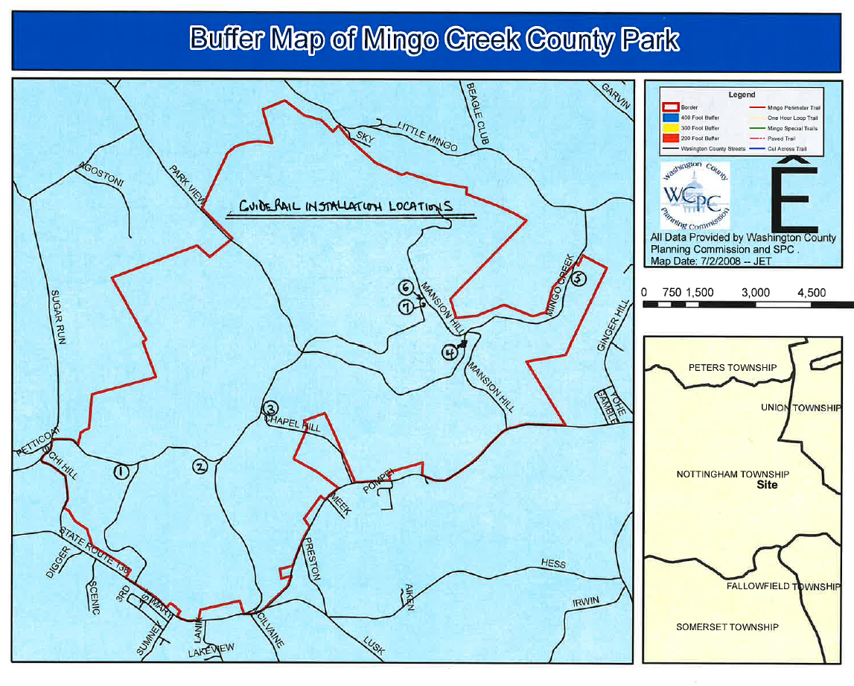

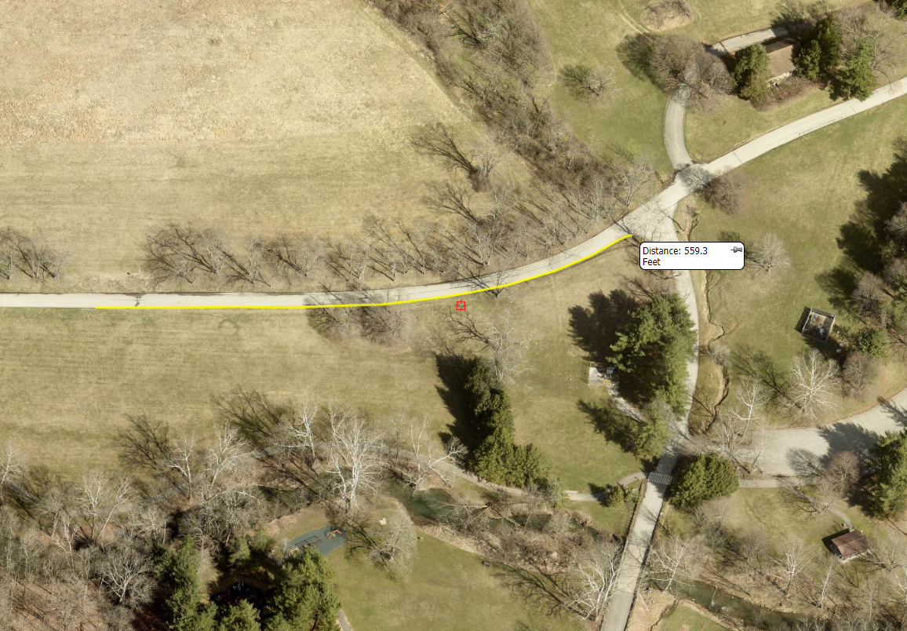
Location 1
562.5 LF Type 2-S Guiderail
2 Each End Terminals
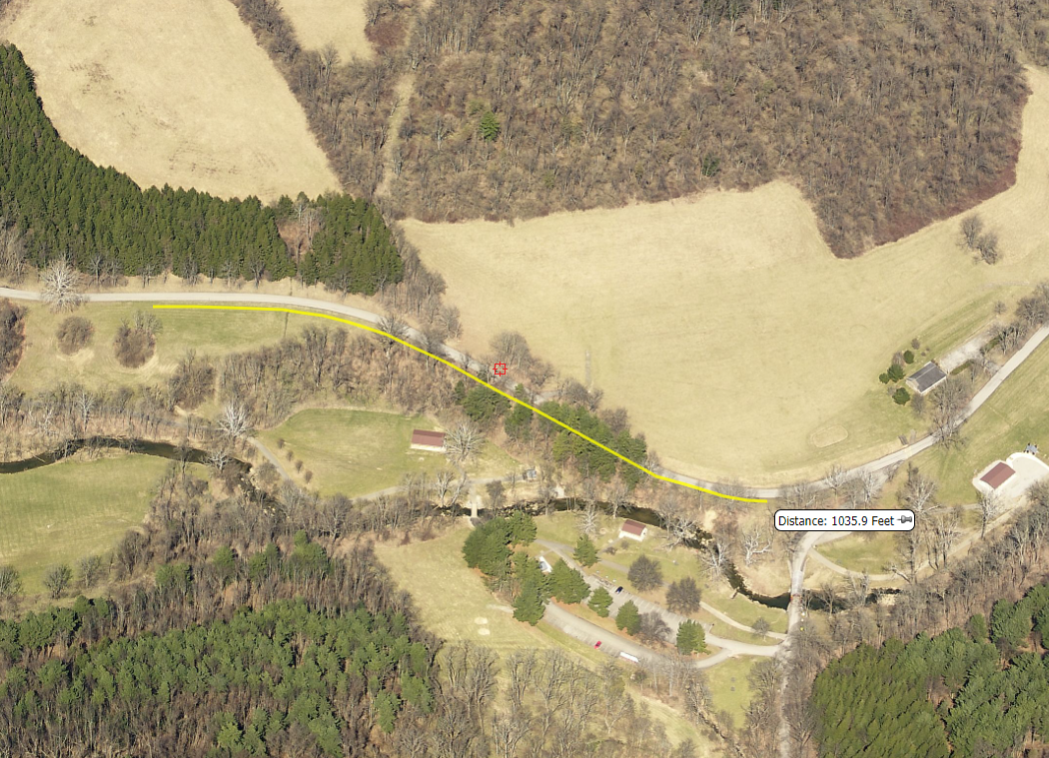
Location 2

1037.5 LF Type 2-S Guiderail
2 Each End Terminals
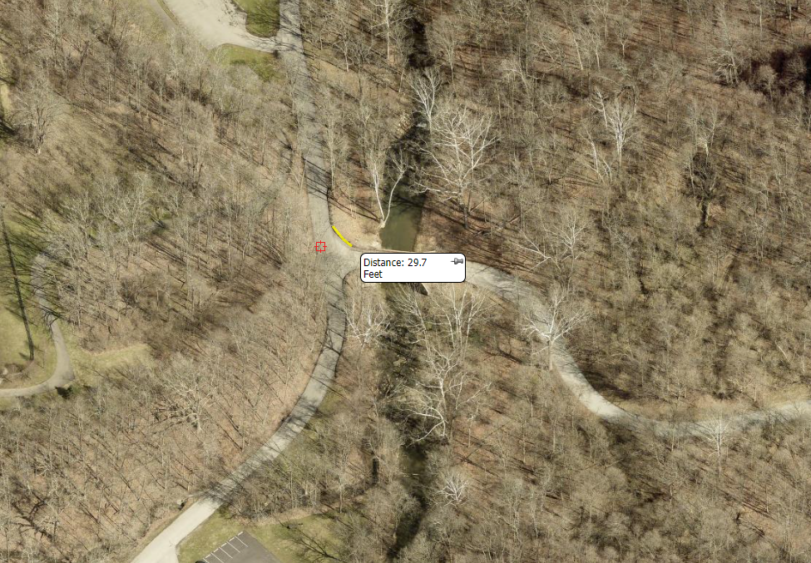
Location 3

25.0 LF Repair 2 each existing damaged guiderail panels Type 2-S Guiderail
Provide curved panels as per existing.
Reset posts and provide replacement hardware as required.

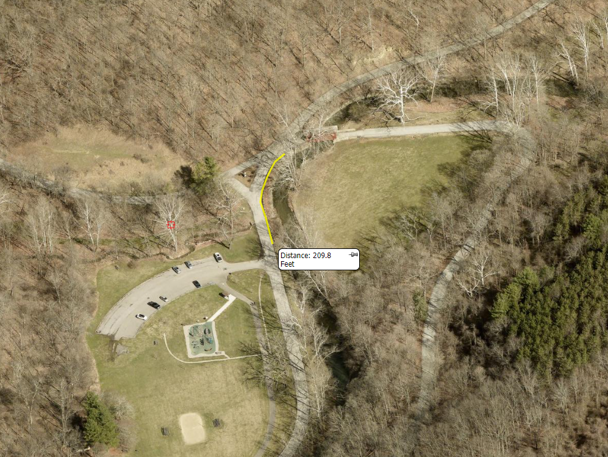
Location 4

212.5 LF Type 2-S Guiderail
1 Each End Terminals
1 Each Terminal Section Bridge Connection
Note: Installation to occur upon completion of intersection roadway work. Anticipated to be completed May, 2024.
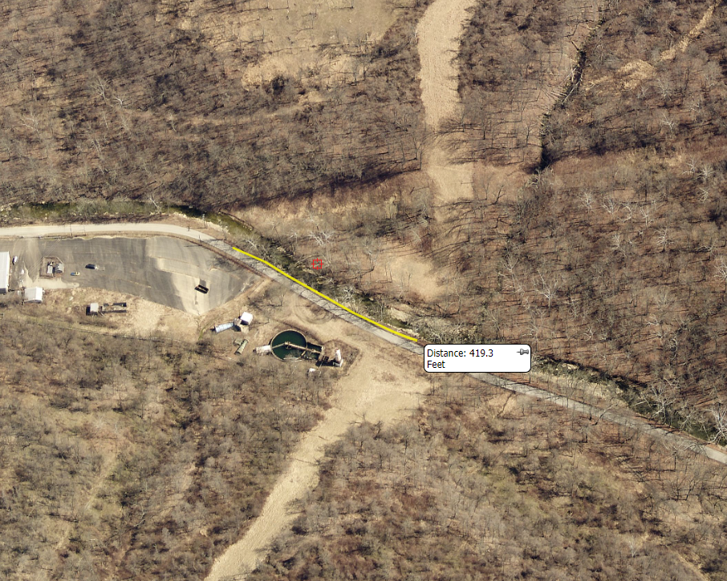
Location 5

425.0 LF Type 2-S Guiderail
1 Each End Terminals
1 Each Connection to Existing Guiderail
14 Each 8 FT Posts
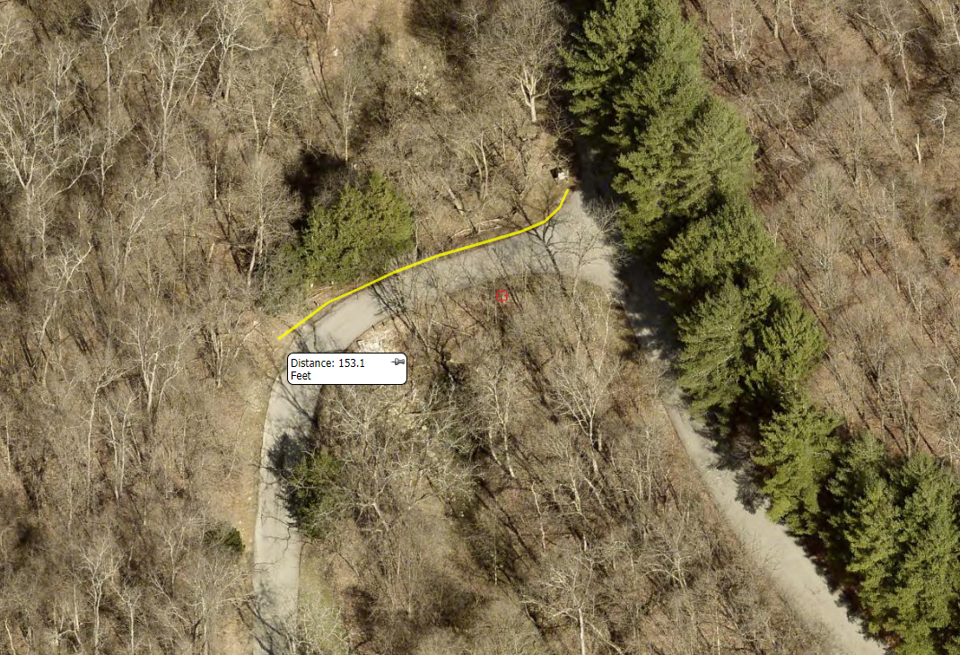
Location 6

162.5 LF Type 2-S Guiderail
1 Each End Terminals
1 Each End Treatment (Buried in bank on trailing end – Class A Anchor Block)
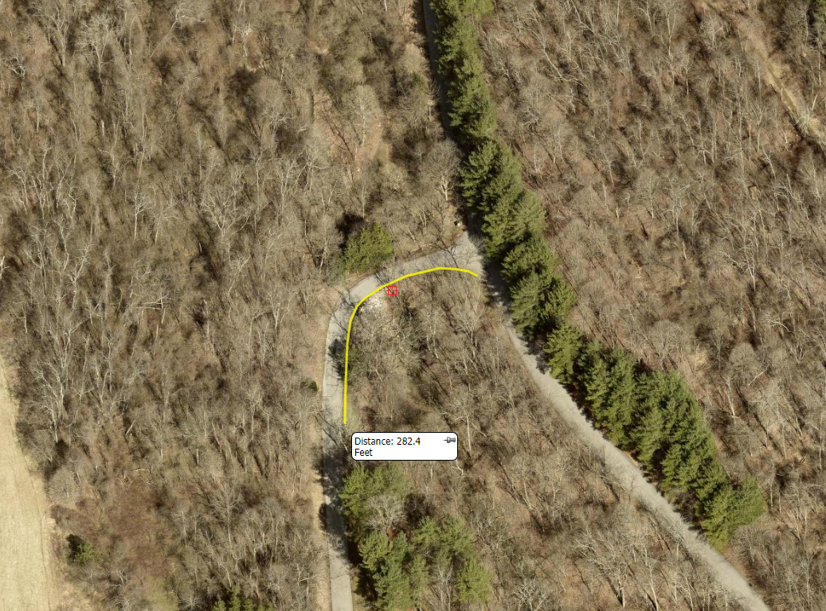
Location 7

287.5 LF Type 2-S Guiderail
2 Each End Terminals
18 Each 8 FT Posts

