WASHINGTON COUNTY NEW PUBLIC SAFETY BUILDING – PHASE 1 DEMOLITION
PRE-BID RFI RESPONSES
February 26, 2025

RFI-001
Could we substitute the Bid Bond form in the specifications for the AIA Bid Bond?

RESPONSE
Yes, AIA Bid Bond Form is an acceptable substitute.

RFI-002
Please confirm the extent of demolition that can be performed on the parking garage to access the 7-story office tower.

RESPONSE
In reviewing the request to reduce reach of the demolition crane (locating the crane closer to the building), removal of the existing garage structure at and below Level A should be minimized. See red area below. The arrow below is at the existing Level D garage entrance. Exterior grades increase between grid lines 4 and 7 (and further east). As such, if the contractor would like to remove the existing garage concrete structure (between Levels A and D) to reduce crane reach, then it is recommended to be limited to between grid lines 5, 6, A and B, WITHOUT DAMAGING ANY EXISTING CONCRETE WALLS, BEAMS AND COLUMNS ALONG THOSE GRID LINES. The position was selected to centrally locate the crane beside the tower AND raise the crane elevation. The removal of structure for more than one bay is not recommended.

Prior to removal, exterior grades shall be adjusted to provide level crane access. In addition, concrete debris shall be positioned at the inside of the garage to adequately brace the existing northern perimeter concrete wall between columns A-5 and A-6. The contractor shall formally submit the procedural sequence (with sketches) to remove the Level A through C structure for the area indicated including the material and installation techniques to install the concrete debris within the building. The demolition contractor’s engineer shall seal the letter and sketches.

In addition, the following shall be performed by the contractor at their own cost.
- Site and building utilities shall be protected or relocated prior to the initiation of any demolition.
- Precast panels shall be removed and adjacent panels re-supported as required to maintain façade stability.
- Construction fall protection along the perimeter of the area removed (at Levels A through C).

Adjustments to the area indicated are permitted however a formal letter indicating the procedural sequence shall be submitted along with sealed calculations indicating the area of removal shall be submitted for review prior to permitting larger areas to be removed.

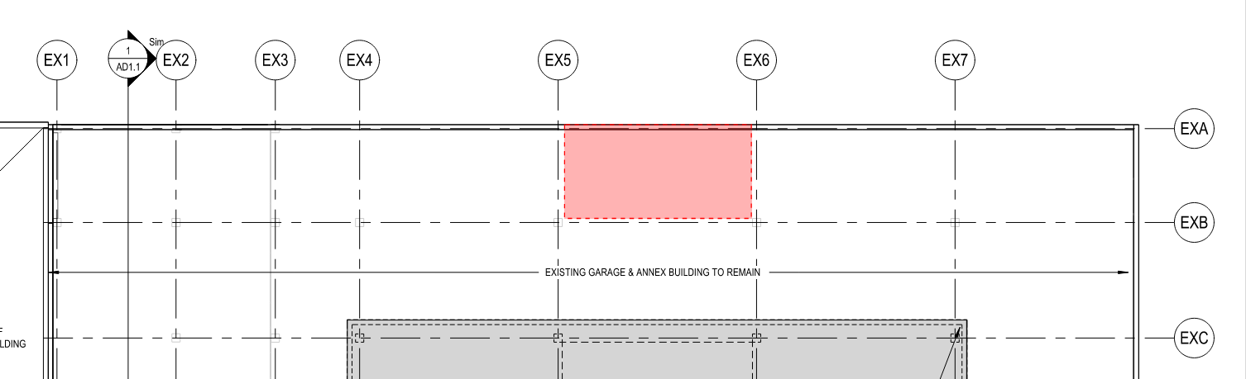

RFI-003
Please confirm that the parking garage is set to be removed post demolition of the tower. The current phasing/Bids sheet has tower Demo & an alternate for the garage demo. Please clarify that the intention is for both tower & garage to be demoed. Will Contractor be able to remove portions/all of the garage structure to create access for our equipment in base bid. How does this affect Bid form? Or please provide an alternate line item on the bid form to remove both the garage and tower at the same time as this modifies means and methods and cost significantly.
RESPONSE
The existing tower is to be demolished down to the plaza level. Any non-structural items are to be demolished in the parking garage. Please see the response to RFI-002 on what elements can be removed from the parking garage to access the tower. Please provide alternate pricing to demolish the tower and parking garage concurrently.
RFI-004
Can the contractor provide alternate pricing for a differing project approach?
RESPONSE
Yes, the Owner will consider value engineering options.

RFI-005
The asbestos survey as shown is incomplete. There is not enough information to bid any asbestos work. Will a complete Hazardous Material Survey be issued/released prior to bids being due? Please confirm that all ACM will be issued as a change order based on a completed survey.
RESPONSE
Please include pricing for the ACM Abatement per the ACM Survey dated May 2024. An additional ACM survey is scheduled and to be performed. Any additional ACM abatement that is required will be handled by a change order.
RFI-006
Please provide drawings for the Family Court Center foundations and retaining wall East of the structure to be removed.
RESPONSE
Drawings for the Family Court Center and returning wall East are not available.

RFI-007
The project could require extensive Geotechnical work or shoring along the East wall. Do you have any geotechnical information available? Is it acceptable if we have an engineer provide a stamped drawing to leave a portion of the garage in place to keep the wall stabilized?
RESPONSE
Please see the attached boring logs. The final Geotechnical Report will be issued once completed. Yes, it is acceptable for an engineer to provide stamped drawings to leave the portion of the garage walls.

RFI-008
What are the specific dust, noise control and vibration measures required for this project, particularly given the proximity to the 911 annex? Are there any restricted work hours due to noise or vibration?
RESPONSE
Per City of Washington Ordinances. Please refer to the City’s website: Home - City of Washington
RFI-009
The contract specifies site cleanup but does not define final site conditions. Is the contractor required to provide final grading and surface treatment (e.g., seeding, paving, or gravel)?
RESPONSE
The existing Level D concrete slab to remain as-is.
RFI-010
Will the Owner accept Contract red lines at bid time.
RESPONSE
Bidders are permitted to submit requested redlines to the contract with their bids, which the County will consider as part of its evaluation of the bids.

RFI-011
Will The contractor be able to use Cherry Ave for any project operations (EX. Crane, material loadout, trucking)
RESPONSE
Yes, as long as the contractor does not interrupt access to the adjacent parking garage.
RFI-012
Please Confirm depth of removal of caisson foundations. Full depth removal is not customary and would require you to provide drawings reflecting depths and size.
RESPONSE
The existing concrete slab on Level D of the parking garage and caissons to remain as-is.
RFI-013
Is the schedule the same for base bid and base bid plus alternate?
RESPONSE
No. The schedule will be revised if the alternate pricing is accepted at time of bid award.
RFI-014
Can the bid due date be extended by 2 weeks?
RESPONSE
Unfortunately, not at this time.

